Using the Giving Main Site
The Giving Main Site allows the most personalization for your Giving.
- To Access the Giving Page - select the link on GoFirst.Org. If you need outside this guide, please use the email under Giving Help
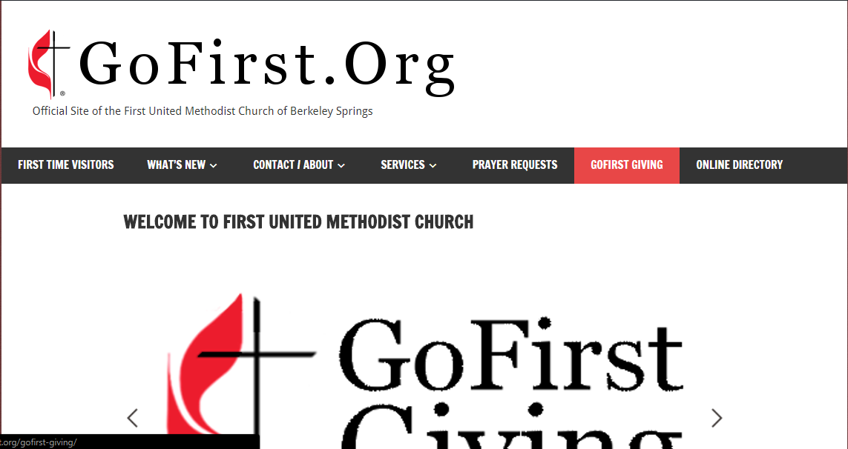
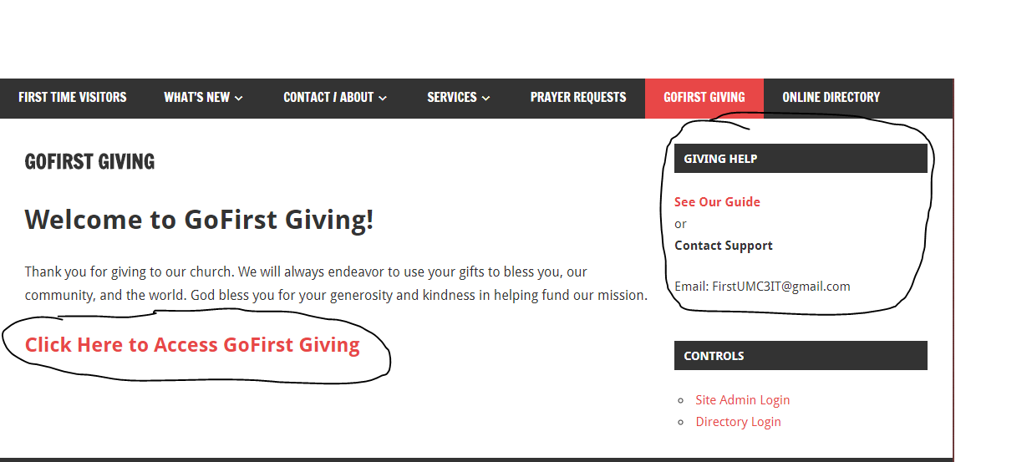

- Once you are on the Main Site enter the amount you would like to give and the frequency of your gift. The giving schedules are as follow:
  - One Time Gifts
  - Weekly Recurring Gifts - 52 Gifts per Year
  - Bi-Weekly Recurring Gifts - 26 Gifts per year
  - Semi-Monthly Recurring Gifts - 24 Gifts per yer
  - Monthly Recurring Gifts - 12 Gifts per year
- You may also input the start and end date of your giving.
  - If you do not select an end date the gift will be processed on the given cycle until you cancel the gift
  - It is recommended you establish one years worth of gifts. This saves you the trouble of manual giving while still allowing you an easy day to know to restart automated giving.
  - You can cancel your giving at anytime.
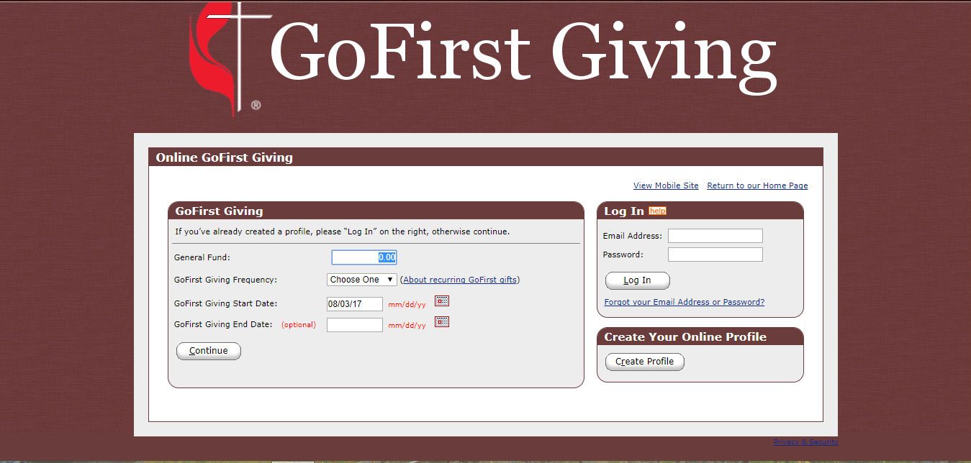

- After you have entered the amount and frequency of your gift a prompt will appear to enter your billing address, account/card information, and to create an account if you wish to manage your recurring giving through the site.
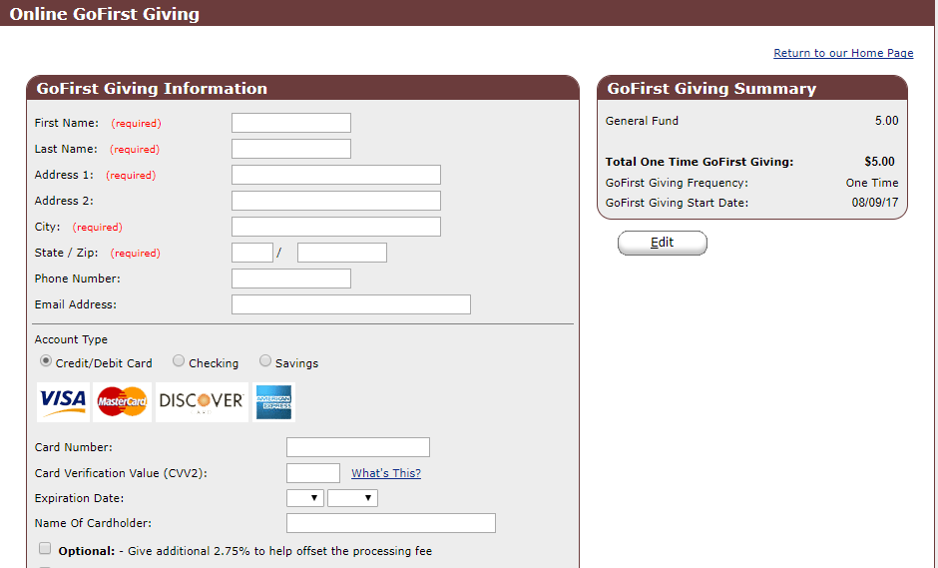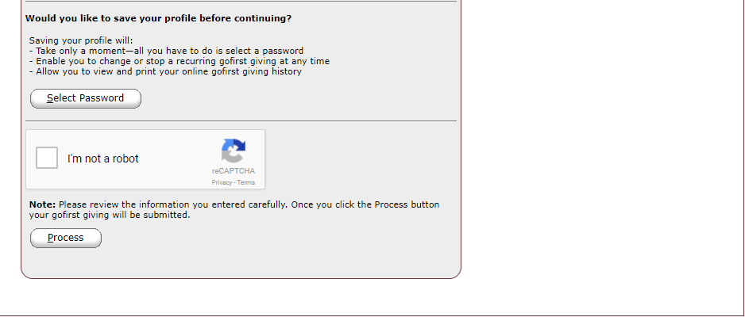
  - If you would like to offset the processing fee of your transaction, please indicate so by checking the box next to Optional in the payment information screen.

- If you have created an account and pressed process you will now be able to access your transaction history. Here you can add additional recurring or one time transactions as needed, as well as edit old transactions.
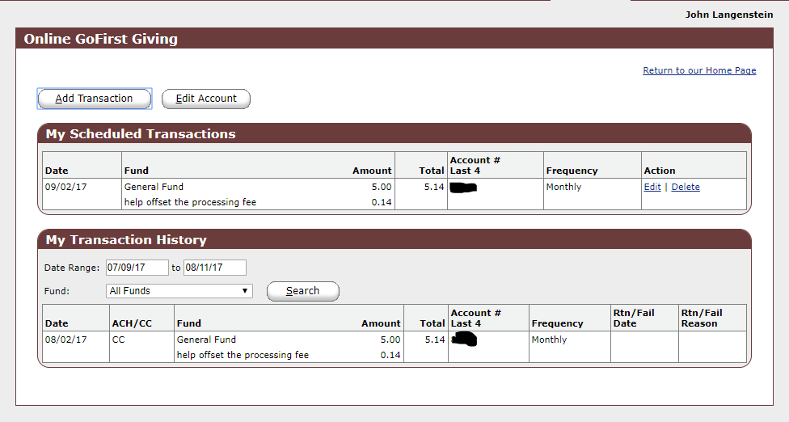

Giving Through App
This App allows for One Time Gifts to be made from your phone to any of our funds -
- Download the Joyfully2UMC App in either the Google Play (Android Users) or App Store (iOS Users)
- Search First United Methodist Church of Berkeley Springs
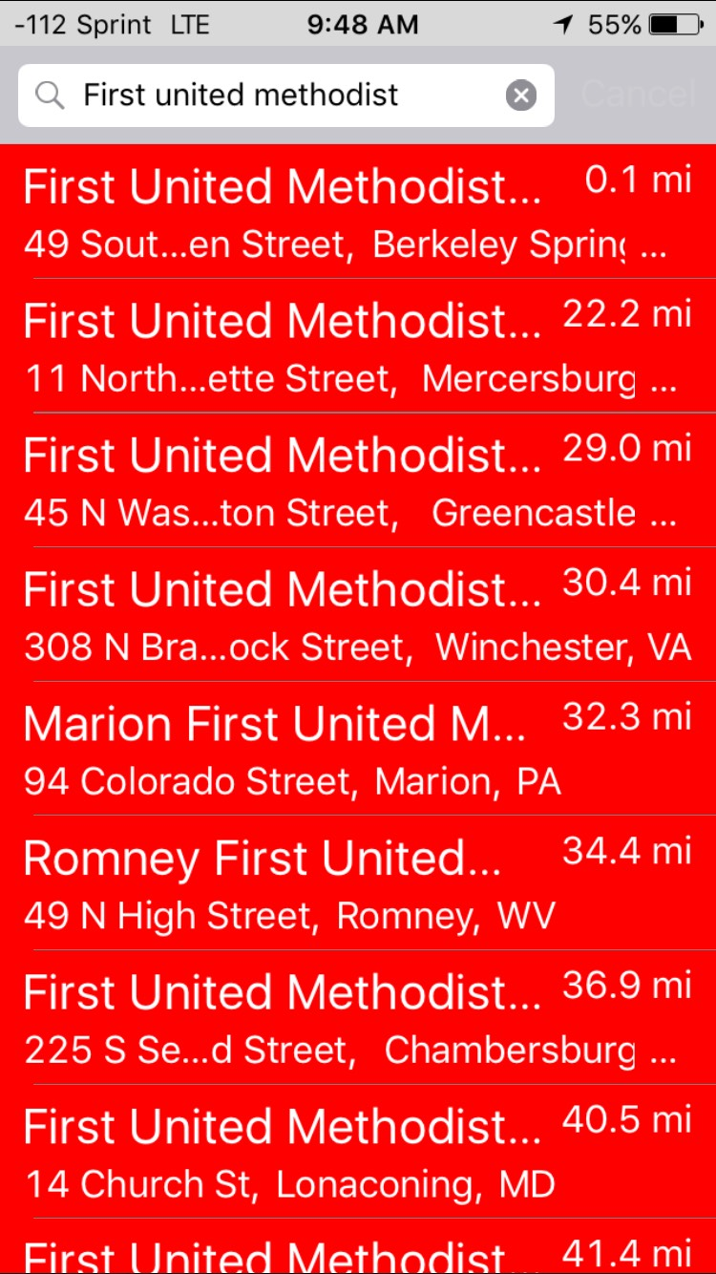

- Select the church and then press the Give option (Appears where Loading is pictured)
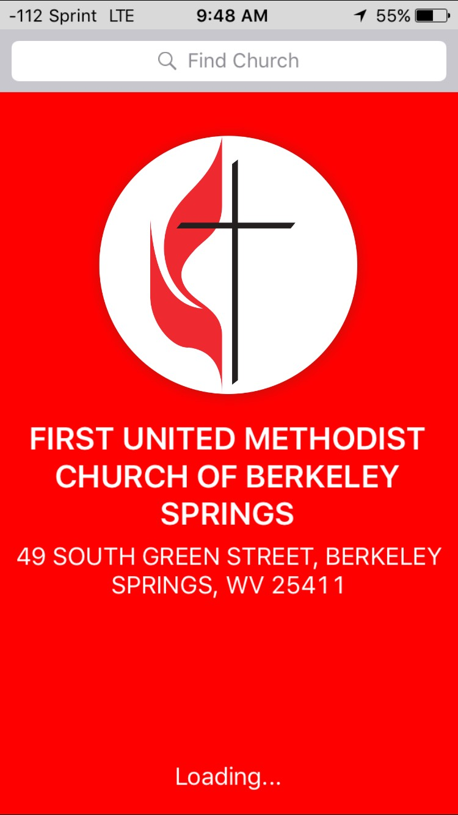

- After a redirect you will be asked to fill out a payment form.
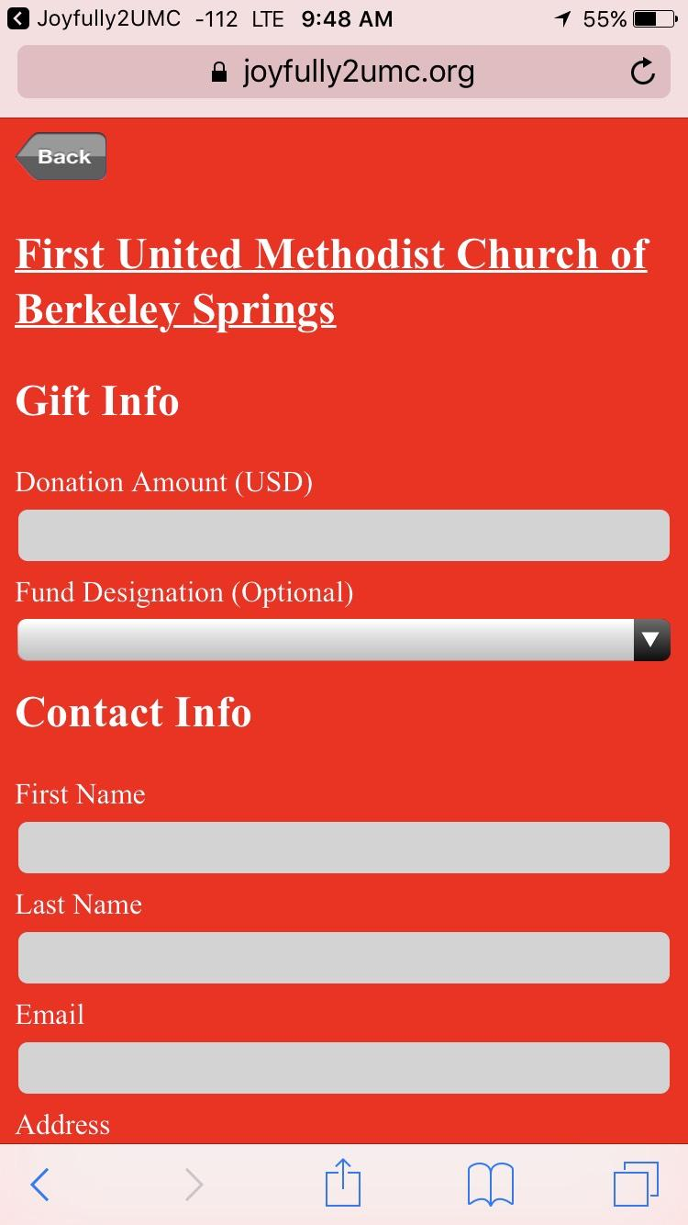
- After this select Give Now and your gift will be processed and a confirmation email sent.

Support
For support please contact firstumc3it@gmail.com, or call the Church office.

Privacy Statement
No information which you put into any payment form on either Gofirst.Org of the GoFirst Giving main site will be saved on our servers. GoFirst Giving is a secure website hosted by Vanco Services, LLC, an industry leader that processes transactions for thousands of clients. Vanco was chosen by First United Methodist Church to process your online transactions. It is a service endorsed by the United Methodist Church Finance and Administration.
The information Vanco receives from you will only be used to process your transactions and will never be shared with any other party, except as required by law. Your information will be safeguarded in strict compliance with federal standards for nonpublic personal information.
The password you select is also important in protecting your information; keep it secure and follow the best practices suggested here. View Vanco’s Privacy and Security Policy by clicking here.
If you would like more information on how First Church keeps your data safe. Please Contact the church office.

